- Pain QVAS
- Muscle Group Charting (Ratings between 0 and 5)

CERVICAL REGION:

SCAPULA MOVEMENT:

ELEVATORS (0 - 5) for all
Upper trapezius (accessory) CN XI, C3-4
Levator scapulae (dorsal scapular) C5, C3-4
DEPRESSORS
Lower trapezius (accessory) CN XI, C3-4
Latissimus dorsi (thoracodorsal) C6-8
ADDUCTORS
Middle trapezius (accessory) CN XI, C3-4
Rhomboids (dorsal scapular) C5
ABDUCTORS
Serratus anterior (long thoracic) C5-7

SHOULDER REGION:
FLEXORS
Anterior deltoid (axillary) C5-6
Coracobrachialis (musculocutaneous) C5-6
Pectoralis major-clavicular (pectoral) C5-6
Biceps (musculocutaneous) C5-6
EXTENSORS
Latissimus dorsi (thoracodorsal) C6-8
Teres major (lower subscapular) C5-6
Posterior deltoid (axillary) C5-6
Triceps-long head (radial) C7-8
ABDUCTORS
Supraspinatus (suprascapular) C5-6
Middle deltoid (axillary) C5-6
ADDUCTORS
Latissimus dorsi (thoracodorsal) C6-8
Teres major (lower subscapular) C5-6
Pectoralis major (pectoral) C5-T1
HORIZONTAL ABDUCTORS
Posterior deltoid (axillary) C5-6
Pectoralis major (pectoral) C5-T1
Anterior deltoid (axillary) C5-6
EXTERNAL ROTATORS
Infraspinatus (suprascapular) C5-6
Teres minor (axillary) C5-6
Posterior deltoid (axillary) C5-6
INTERNAL ROTATORS
Subscapularis (upper, lower subscapular) C5-7
Teres major (lower subscapular) C6-7
Latissimus dorsi (thoracodorsal) C6-8
Pectoralis major (pectoral) C5-T1
Anterior deltoid (axillary) C5-6

ELBOW REGION

FLEXORS
Biceps (musculocutaneous) C5-6
Brachioradialis (radial) C5-7
Brachialis (musculocutaneous) C5-6 (radial) C7-8
EXTENSORS
Triceps (radial) C6-8
FOREARM PRONATORS
Pronator teres (median) C6-7
Pronator quadratus (median) C8-T1
FOREARM SUPINATORS
Supinator (radial) C5-6
Biceps (musculocutaneous) C5-6

WRIST REGION

EXTENSORS
Ext. carpi radialis longus (radial) C6-7
Ext. carpi radialis brevis (radial) C7-8
Ext. carpi ulnaris (radial) C7-8
FLEXORS
Flexor carpi radialis (median) C6-7
Palmaris longus (median) C7-8
Flexor carpi ulnaris (ulnar) C8-T1

KNEE REGION

FLEXORS
Hamstrings (tibial) L5-S2
EXTENSION
Quadriceps (femoral) L2-4

ANKLE REGION

DORSIFLEXION
Tibialis anterior (deep peroneal) L4-S1
Extensor digitorum longus (deep peroneal) L4-S1
Extensor hallucis longus (deep peroneal) L4-S1
PLANTARFLEXION
Gastrocnemius (tibial) S1-2
Soleus (tibial) S1-2

Source: Occupational therapy for physical dysfunction

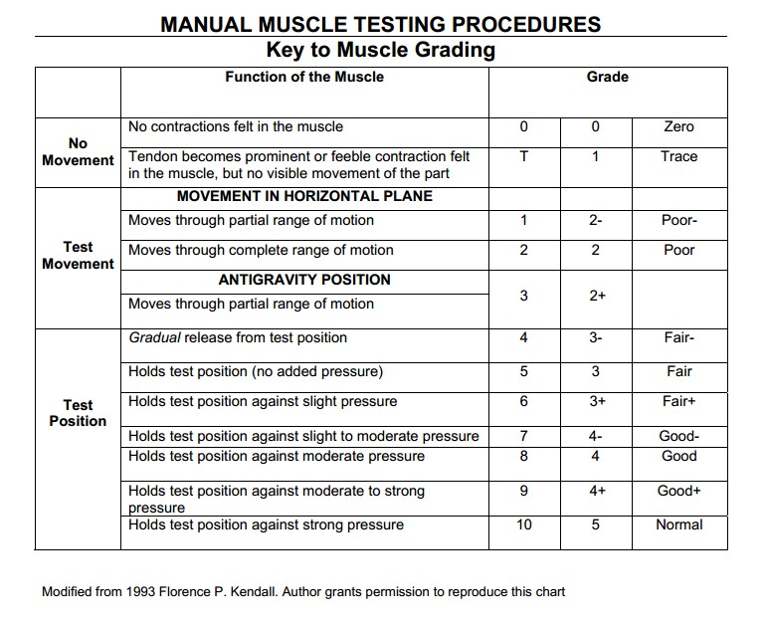
- Range of Motion Measurement

CERVICAL REGION

Flexion 0°- 45°
Extension 0°- 45°
Lateral flexion 0° - 45°
Rotation 0° - 60°

SHOULDER REGION

Flexion 0–180
Extension 0–60
Abduction 0–180
Horizontal abduction 0–90
Horizontal adduction 0–45
Internal rotation 0–70
External rotation 0–90
Internal rotation (alt) 0–80
External rotation (alt) 0–60

LUMBAR REGION

Flexion 0° - 80°
Extension 0° - 30°
Lateral flexion 0° - 40°
Rotation 0° - 45°

ELBOW REGION

Flexion–extension 0–150
Supination 0–80
Pronation 0–80

WRIST REGION

Flexion 0–80
Extension 0–70
Ulnar deviation 0–30
Radial deviation 0–20

KNEE REGION

Flexion 0° - 135°

ANKLE REGION

Plantar flexion 0° to 50°
Dorsiflexion 0° to 15°
Inversion 0° to 35°
Eversion 0° to 20°

- Myotome Assessment: Assessment of muscles innervated by a single spinal nerve root

- C5- shoulder abduction.
- C6– Elbow flexion Wrist extension
- C7 – Elbow extension
- C8 – Thumb Extension and wrist ulnar deviation
- T1 – Finger abduction
- L2 – Hip flexion
- L3 – Knee extension
- L4 – Ankle dorsiflexion
- L5 – Big toe extension
- S1 – Ankle plantarflexion
- S2 - Knee flexion

- Dermatome Assessment
Nerve Root Dermatome
Cervical
C2 Supply Skin of Neck - Temple, Forehead, Occiput
C3 Entire Neck, Posterior Cheek, Temporal Area, Prolongation forward under Mandible
Shoulder/Elbow Region
C4 Shoulder Area, Clavicular Area, Upper Scapular Area
C5 Supply the Arms Deltoid Area, Anterior aspect of entire arm to base of thumb
C6 Anterior Arm, Radial side of hand to thumb and index finger
C7 Lateral Arm and Forearm to index, long, and ring fingers
C8 Medial Arm and forearm to long, ring, and little fingers
T1 Medial side of forearm to base of little finger
T2 Supply the chest and abdomen - Medial side of upper arm to medial elbow, pectoral and mid-scapular areas
T3 - 6 Upper Thorax
T5 - 7 Costal Margin
Lumbar Region
T8 - 12 Abdomen and Lumbar Region
L1 Back, over trochanter and groin
L2 Back, front of thigh to knee
L3 Supply Skin of Legs - Back, upper buttock, anterior thigh and knee, medial lower leg
L4 Medial buttock, latera thigh, medial leg, dorsum of foot, big toe
L5 Buttock, posterior and lateral thigh, lateral aspect of leg, dorsum of foot, medial half of sole, first, second, and third toes
S1 Buttock, Thigh, and Leg Posterior
S2 Supply Groin Same as S1
S3 Groin, medial thigh to knee
S4 Perineum, genitals, lower sacrum
Coccygeal The dermatome corresponding with the coccygeal nerves is located on the buttocks, in the area directly around the coccyx
Source: Physiopedia

